  Lab 2-1  Basic Logic Gate Implementation – Part 2  Group : 14  Name : 黃翊宏 Student ID : 01357101 |  | Notice  Lab report must be submitted in PDF format.  Lab report must be submitted to the TronClass by 13:00 next class hour.  Each student must submit one lab report.  File name of the lab report must be in Lab#_StudentID.

- Lab 2-1
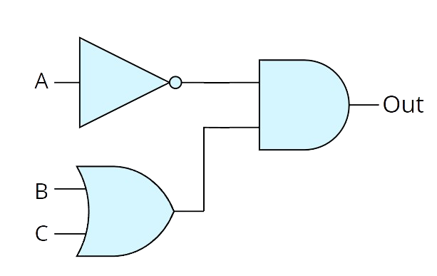
Truth Table (Voltage) |  |  |  | Truth Table (Logic)
A | B | C | out | A | B | C | out
0 | 0 | 0 | 0.17 | 0 | 0 | 0 | 0
0 | 0 | 1 | 2.98 | 0 | 0 | 1 | 1
0 | 1 | 0 | 2.98 | 0 | 1 | 0 | 1
0 | 1 | 1 | 2.98 | 0 | 1 | 1 | 1
1 | 0 | 0 | 0.17 | 1 | 0 | 0 | 0
1 | 0 | 1 | 0.17 | 1 | 0 | 1 | 0
1 | 1 | 0 | 0.17 | 1 | 1 | 0 | 0
1 | 1 | 1 | 0.17 | 1 | 1 | 1 | 0
Breadboard Wiring Photos
(Output must be connected to an LED and clearly labeled)
A = 0；B = 0；C = 0 |  |  |  | A = 0；B = 0；C = 1
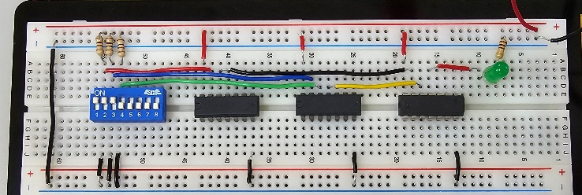 |  |  |  | 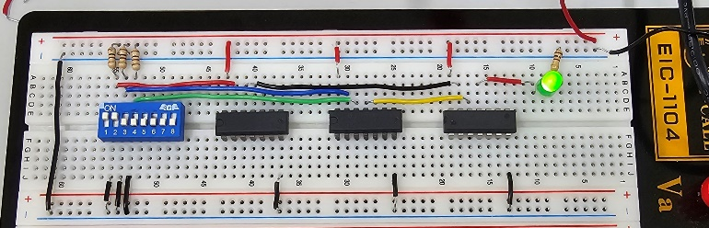
A = 0；B = 1；C = 0 |  |  |  | A = 0；B = 1；C = 1
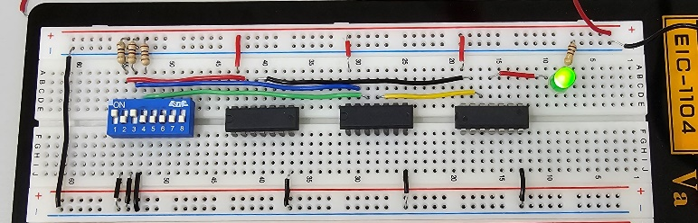 |  |  |  | 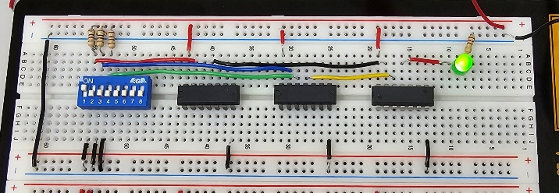
A = 1；B = 0；C = 0 |  |  |  | A = 1；B = 0；C = 1
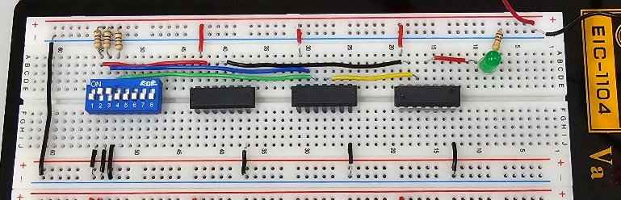 |  |  |  | 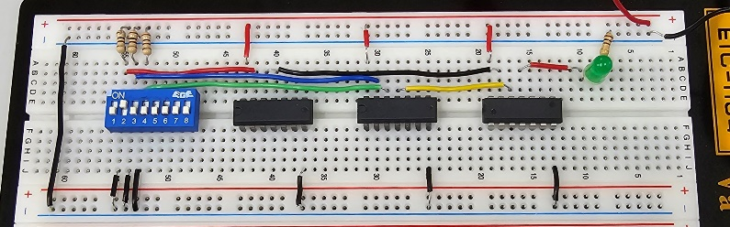
A = 1；B = 1；C = 0 |  |  |  | A = 1；B = 1；C = 1
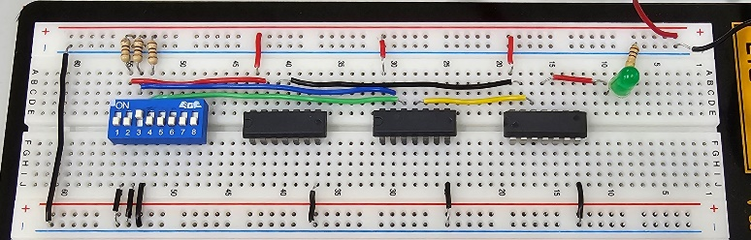 |  |  |  | 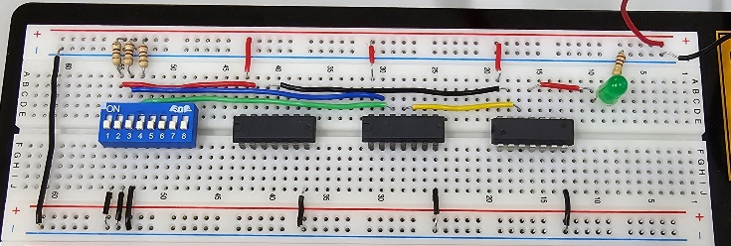

- Lab 2-2
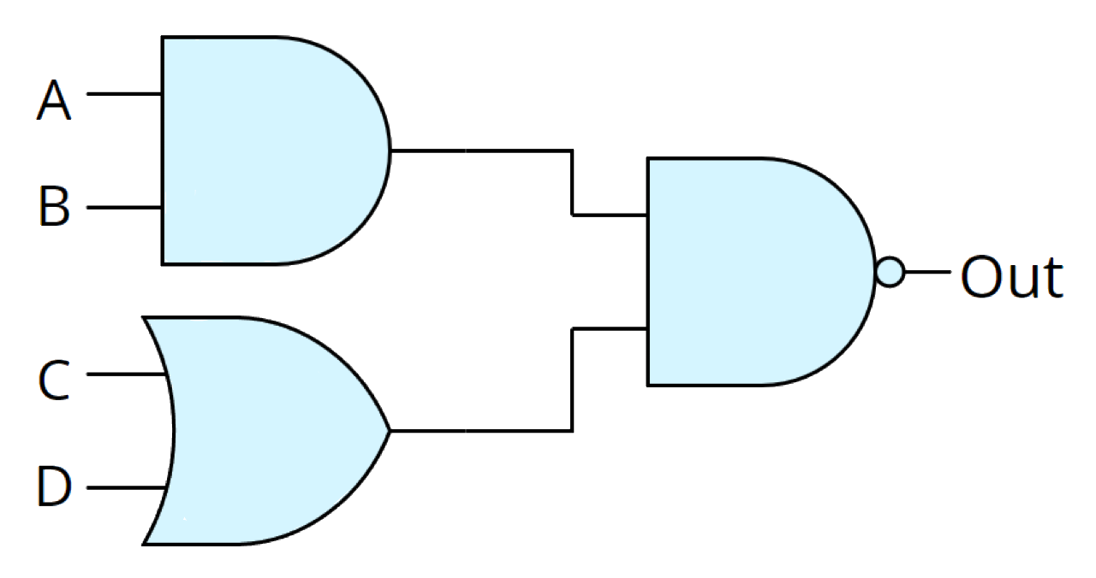
Truth Table (Voltage) |  |  |  |  | Truth Table (Logic)
A | B | C | D | out | A | B | C | D | out
0 | 0 | 0 | 0 | 2.92 | 0 | 0 | 0 | 0 | 1
0 | 0 | 0 | 1 | 2.92 | 0 | 0 | 0 | 1 | 1
0 | 0 | 1 | 0 | 2.92 | 0 | 0 | 1 | 0 | 1
0 | 0 | 1 | 1 | 2.92 | 0 | 0 | 1 | 1 | 1
0 | 1 | 0 | 0 | 2.92 | 0 | 1 | 0 | 0 | 1
0 | 1 | 0 | 1 | 2.92 | 0 | 1 | 0 | 1 | 1
0 | 1 | 1 | 0 | 2.92 | 0 | 1 | 1 | 0 | 1
0 | 1 | 1 | 1 | 2.92 | 0 | 1 | 1 | 1 | 1
1 | 0 | 0 | 0 | 2.92 | 1 | 0 | 0 | 0 | 1
1 | 0 | 0 | 1 | 2.92 | 1 | 0 | 0 | 1 | 1
1 | 0 | 1 | 0 | 2.92 | 1 | 0 | 1 | 0 | 1
1 | 0 | 1 | 1 | 2.92 | 1 | 0 | 1 | 1 | 1
1 | 1 | 0 | 0 | 2.92 | 1 | 1 | 0 | 0 | 1
1 | 1 | 0 | 1 | 0.12 | 1 | 1 | 0 | 1 | 0
1 | 1 | 1 | 0 | 0.12 | 1 | 1 | 1 | 0 | 0
1 | 1 | 1 | 1 | 0.12 | 1 | 1 | 1 | 1 | 0
Breadboard Wiring Photos
(Output must be connected to an LED and clearly labeled)
A = 0；B = 0；C = 0；D = 0 |  |  |  |  | A = 0；B = 0；C = 1；D = 0
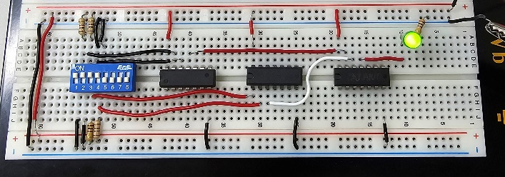 |  |  |  |  | 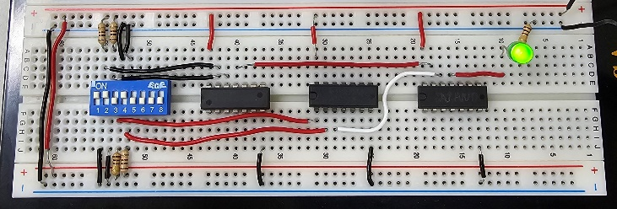
A = 0；B = 1；C = 0；D = 1 |  |  |  |  | A = 0；B = 1；C = 1；D = 1
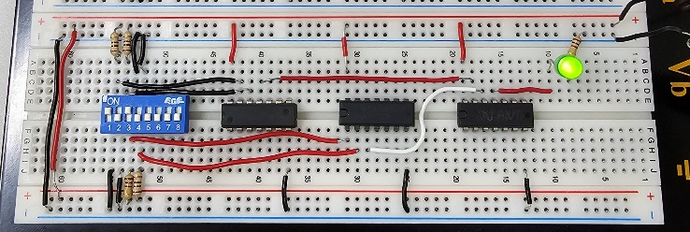 |  |  |  |  | 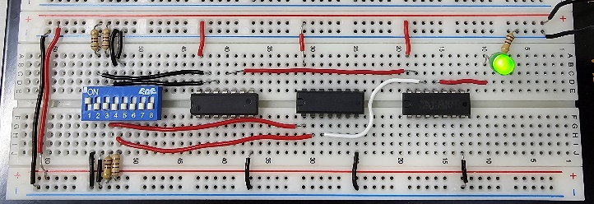
A = 1；B = 0；C = 0；D = 0 |  |  |  |  | A = 1；B = 0；C = 1；D = 0
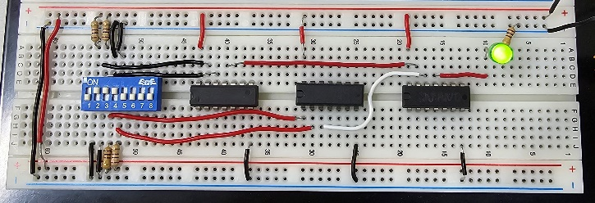 |  |  |  |  | 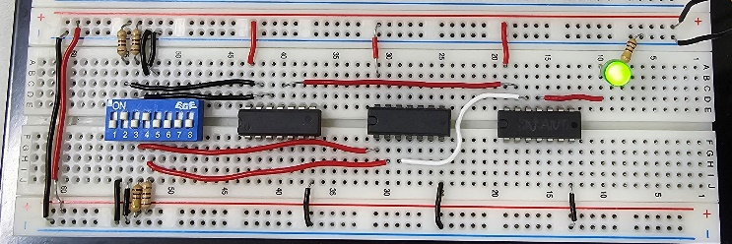
A = 1；B = 1；C = 0；D = 1 |  |  |  |  | A = 1；B = 1；C = 1；D = 1
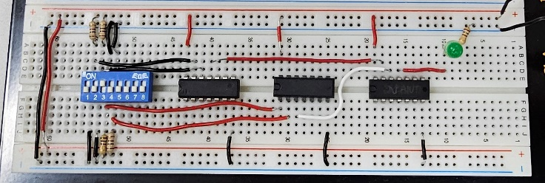 |  |  |  |  | 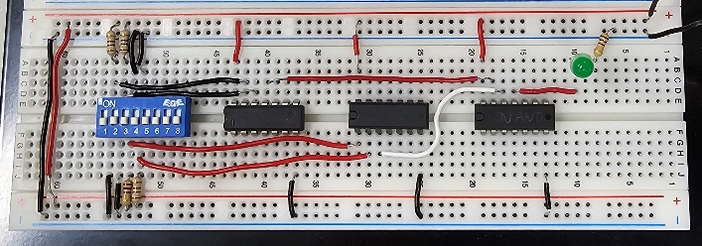

Lab Summary and Reflection：

